DEVELOPMENT OF STUDENTS’ ENGLISH FOR SPECIAL PURPOSES COMPETENCE IN TOURISM STUDIES AT TERTIARY LEVEL

Ineta Luka
The Department of Foreign Languages,
School of Business Administration Turiba

Graudu 68, Riga LV-1058, Latvia
E-mails: Ineta@turiba.lv and ineta.luka@inbox.lv Fax: +371 67619152

BIODATA OF AUTHOR
Dr.paed. Ineta Luka is Associate Professor, the Head of the Foreign Languages department of the School of Business Administration Turiba, Latvia. The courses taught: “English for Special Purposes” and “Pedagogy of Higher Educational Institutions”. Research fields: ESP competence, language pedagogy, higher education, adult education and lifelong learning. The author of the monograph on language teaching-learning at tertiary level studies, the author of 22 and co-author of 6 scientific papers, has presented in international scientific conferences, symposiums and congresses in Latvia, Lithuania, Estonia, Poland, Sweden, Finland, China and Austria, has received 4 awards for scientific contribution in language teaching-learning.

Abstract

The topicality of the present evaluation research is marked by the changes in teaching-learning process, which is shifting from teaching to learning. The study implementing a mixed method research design was conducted from 2003 to 2007 in the fourth largest tertiary education institution of Latvia, which among other programmes provides well-acknowledged higher education in tourism. The goal of the research was to study the efficiency of the English language learning model in the development of tourism specialist’s English for Special Purposes (ESP) competence.
ESP competence components, criteria and indicators were defined; the description of the competence levels was made. Based on the ideas derived from action theory and social constructivism theory, and the results of the analysis of curriculum and syllabus theories and competence theories, the model for the development of tourism students’ ESP competence was constructed and validated in the studies, suggestions for ESP educators were elaborated. The created model promotes students’ language competence and educator’s professional activity, the language becomes a means of acquiring one’s profession.
Keywords: language competence, ESP competence, competence development, process, cooperation
Abbreviations: ESP – English for Special Purposes

1. Introduction

The twenty-first century is characterized by ever-increasing flow of information and technical modernization, which influence people’s mobility, dynamics and constructivism. The exchange of information does not take place only in a single country but a wide cooperation between countries in the fields of economics, culture, education, science and politics is developing. In these conditions the demands to employees’ professionalism are growing which set new requirements to education, stressing “co-existence, respect to personality, dialogue, mutual creative activity” (Alijevs, 2005, p. 57). In knowledge society the content of the studies, the methods used and the requirements for an educator’s professionalism are changing. S. L. Robertson (2005) considers that in knowledge society the aim of education is not only to educate professionals for a certain field but it has to help students to be aware of cultural values, form human mutual relationship, collaborate, be open, adapt to the new situation, creatively express their ideas, accept responsibility and challenge.
Ability in practice use new competences may be developed by implementing a competence-based learning approach whose advantage is a systemic approach in creating an integrated curriculum which comprises wide spheres of education, as well as a student-centred curriculum designed based on the results of a needs analysis (Chishimba, 2001). Besides, this approach is a way to reach a situation when academic knowledge and long-term employability become compatible goals of higher education (Reichert, Tauch, 2003, 2005).
Such a model may be used in tourism studies as well as its aim is to educate creative, knowledgeable specialists with a good command of several foreign languages, who are able to make decisions and work observing traditions of different cultures. Tourism specialists must possess good communication skills and a high level of intercultural competence as they have to use language in different socio-cultural contexts. Therefore, with the growth in requirements for language competence, the language-learning model changes, as well.
The various existing definitions and classifications of the English language competence do not include the specifics of tourism business, therefore there was an objective need to study possibilities how students could attain a high level of English for Special Purposes (ESP) competence, the ability to compete in labour market and to continuously develop themselves, how to promote the development of educator’s professional pedagogical activity and how to integrate ESP in studies. Thus the problem of the research was double-sided – how to bring studies nearer to professional activity and how to further an educator’s professional help for students in order to activate their purposeful and meaningful participation in the studies and to promote the development of students’ ESP competence so that prospective tourism specialists could wholeheartedly express themselves and be competitive in the labour market.
The goal of the research was to study the efficiency of the English language learning model in the development of tourism specialist’s ESP competence.
The following tasks specify the goal: to analyze theoretical literature and sources on curriculum and syllabus design, the components and development of general competence, professional competence, the English language competence and ESP competence; define tourism specialists’ ESP competence, its criteria, indicators and make a description of competence levels; design an ESP syllabus; create a model for the development of students’ ESP competence, validate it and introduce into the studies; on the background of the created model and conducted empirical research elaborate suggestions for the development of ESP educators’ professional activity.

2. Theoretical Framework

2.1. ESP Curriculum design
Any course design starts with needs analysis (Elliott, 1998; Gillet, 1989; More, 2001; Nunan, 1991), which is conducted on several levels: on the level of a students’ group, on institutional, educational, administrative, political and cultural level (Kennedy, 1988). Needs analysis is a component of a system approach and it can be defined as procedures that are carried out in order to get information about students’ wishes (Richards, 2001).
Next, curriculum and syllabus theories were analyzed. In order to make the content of an ESP course, the difference between curriculum and syllabus had to be revealed. Considering the opinions expressed by D. Nunan (1991), N. Markee (2002) and J. Elliott (1998), in this study an approach where curriculum implies educational philosophy, aims of the course, the selected teaching-learning methods and teaching aids but syllabus includes the course content (what is to be taught and in what sequence) was adopted.
The analysis of theoretical literature concerning different syllabi types, their advantages and disadvantages was done in order to choose the most appropriate syllabi for an ESP course for tourism students (Markee, 2002; Yalden, 1996; Willis, 1998; Reilly, 1988; Dunkelman, 1996; Nunan, 1991; Widdowson, 1979; Ellis, 2005; Rabbini, 2002; Rooney, 2000; Skelton, Willis, 2004; Bell, 1981; Foster, 1999). A conclusion was drawn that the integrated syllabus should be designed. Topical syllabus was chosen as the leading syllabus and situational, task-based and process syllabi were used as the supplementary ones. The use of topical and situational syllabi ensures its content correspondence to the requirements of the tourism industry. The elements of the task-based syllabus help to develop students’ communication skills, creative thinking and problem-solving skills, but the elements of process syllabus enable its innovative approach as the course content, teaching-learning methods and teaching aids are selected in co-operation between students and an educator.

2.2. Approach to competence theory
In order to define ESP competence, its criteria and indicators, competence theories were analyzed.
Historically competence has been associated with skills, qualification and abilities. The latest approach to the competence theory regards competence as an ideal of education and an analytical category (Maslo, I., & Tiļļa, 2005; Maslo, I., 2006, Tiļļa, 2003; 2005) admitting that “competence is an individual combination of abilities and experience” (Tiļļa, 2005, p. 36). Thus the structure of competence is formed by experience that includes knowledge, skills and attitude, and abilities, which determine an individual’s readiness for activity. Experience and abilities are essential factors for every individual in order to attain their professional and personal goals. Competence development takes place in an action, which is based on an individual’s personal experience, as a result forming new experiences.
2.3. ESP competence for tourism specialists

2.3.1. Professional competence for tourism specialists
The studies in competence theory reveal several approaches to competence classifications stressing the most important competences essential both in successful professional activity and in personal life.
OECD defines three categories of competences: an ability to operate in socially heterogeneous groups, an ability to act autonomously and an ability to use tools interactively (The Definition and Selection of Competencies, 2008). Language learning is connected with all the three categories, as learning takes place cooperating with group mates and the educator, as well as using a language interactively.
A European Reference Framework for key competences for lifelong learning stresses eight key competences: “communication in mother tongue; communication in foreign languages; mathematical competence and basic competences in science and technology; digital competence; learning-to-learn; interpersonal, intercultural and social competences and civic competence; entrepreneurship; and cultural expression” (Proposal for a Recommendation of the European Parliament and of the Council on key competences for lifelong learning, 2005, p. 19). Communication in foreign languages is based on the ability to understand an idea, express and explain thoughts, feelings and facts both orally and in a written form in a versatile socio-cultural context. Communication in one’s native tongue and in foreign languages influences the development of all the other competences as language influences the way we are thinking (Bernstein, Penner, et al., 2003; Vigotskis, 2002).
D. Wilson (2001) points out personal, technologically-professional and intercultural competences. M. Print, S. Ørnstrøm, H. S. Lielsen (2002) mention three groups of competences: cognitive, emotional and social competences, but P. Renard’s (2001) competence clasification coincides with the key competences for lifelong learning.
Based on these competence classifications it is concluded that tourism specialists’ professional activity competence consists of cognitive competence (theoretical and practical knowledge of the industry), personal competence (communication abilities and social skills) and technologically-professional competence (creative and constructive problem solving, communication skills, cooperation).
Based on theoretical review of the theories of professional competence the definition of professional competence was elaborated: tourism specialist’s professional competence is an individual combination of gained experience, attitude and abilities developed on the basis of learning which allows a specialist to think strategically, untraditionally implement knowledge, responsibly develop tourism industry and creatively work in tourism profession observing traditions and peculiarities of different cultures.

2.3.2. Communicative competence for tourism specialists
Several approaches to language learning have gained popularity in different historic periods. It can be explained by definite requirements of the society and tendencies in language use. Since 1970ies communicative language competence development model has been one of the most popular language learning models in the world. One of the most popular approaches of communicative competence (Canale, Swain, 1980) treats it as knowledge and skills necessary for communication. L.F. Bachman and A.S. Palmer (1982) consider that communicative competence is connected with morphology, syntax, lexis, cohesion and organization of the text. E. Tarone and G. Yule (1989) elaborated M. Canale and M. Swain’s classifications of communicative competence (Canale, Swain, 1980; Canale, 1983a, 1983b) and they associate communicative competence with an ability to form and understand syntax, lexis, phonology of the language and ability to use a language according to the socio-cultural context and effectively pass information to the partner, including an ability to use communication strategies to solve the problems that have arisen in the communication process.
In this study H.G. Widdowson’s definition of communicative competence is used: “communicative competence is a set of strategies or creative procedures for realizing the value of linguistic elements in contexts of use, an ability of make sense as a participant in discourse, whether spoken or written, by the skilful deployment of shared knowledge of code resources and rules of language use” (Widdowson, 1979, p. 240).
Thus communicative competence includes: grammatical competence (basic lexis, semantics, morphology, syntax, phonology and orthography), pragmatic competence (contextual lexis, language functionality, unity and continuity of communication), discourse competence (language exposure and the unity of text and situation), sociolinguistic competence (understanding of other cultures, register, accent, dialects and interaction skills) and strategic competence (verbal and non-verbal communication strategies and compensation strategies).
During the last decade language communicative competence has included cultural knowledge and exposure (Lund, 1996; Byram, 1998; McKay, 2002; Dirba, 2003) but none of the existing classifications pays attention to language for professional purposes.

2.3.3. Intercultural competence for tourism specialists
Nowadays communicative competence without awareness of cultural dimensions in language use is not complete. In language learning it is important to be aware of its cultural aspect, because knowledge about other cultures helps to learn a language and assess cultural values and peculiarities of the language learner’s nation (Anisimova, 2006; Dirba, 2003; Ellis, 2005; Kim, & Hall, 2002; Korhonen, 2004; Stier, 2004; Williams, & Burden, 1999).
According to M. Byram intercultural competence includes attitude, knowledge, interpretation and relating skills, discovery and interaction skills, and critical awareness of culture or political education (Byram, 2000).
Intercultural competence may be divided into two groups: content-competence and process-competence. Content-competence refers to “the knowing that-aspects of culture” (knowledge of history, language, behaviour, cultural norms, habits, customs, symbols, traditions, etc.). Process-competence refers to the dynamic character of intercultural competence and its interactional context or “the knowing how-aspect of intercultural competence”. Process-competence consists of intrapersonal competencies (perspective alteration, self-reflection, role-taking, problem-solving, culture-detection and axiological distance) and interpersonal competencies (interpersonal sensitivity, communication competence and situational sensitivity) (Stier, 2006; 2004).
Developing intercultural competence is a rather slow learning process, which includes learning a foreign language, intercultural training and gaining experience from meeting people of other cultures (Korhonen, 2004). Students also have to acquire theoretical and practical cultural knowledge, which can be done through intercultural communication.
Nowadays communicative competence without awareness of cultural dimensions in language use is not complete. Language users must possess intercultural communicative competence. It is formed by communicative competence and intercultural competence and it consists of several sub-competences that are interacting and influencing each other (Byram, 2000; Byram, Gribkova, 2002; Dirba, 2003, 2004).
In this study intercultural competence is referred to as an ability to see and understand differences in one’s own and other people’s cultures and countries, accept them and accordingly react, in conversation and behaviour treating people in a way, which is not offending, scornful or insulting to the members of other cultures. At the same time it includes the knowledge of one’s own nation and culture, awareness of their values, their preservation and development.
Intercultural competence consists of attitude (inquisitiveness and openness, tolerance), declarative knowledge of cultural aspects (facts, concepts) (Dirba, 2004) and an ability to operate in different cultural contexts.

2.3.4. ESP competence definition, criteria and indicators
To sum up, ESP competence consists of communicative, intercultural and professional activity competence. Each of them consists of several sub-competences that interact. The development of ESP competence takes place in action and it is based on students’ experiences, and consequently students form new experiences (see Fig. 1).
ESP competence is an individual combination of gained experience, attitude and abilities developed on the basis of learning, which allows a specialist, observing different cultural traditions and peculiarities, to creatively implement the English language both receptively and productively in communication and professional work, responsibly develop tourism industry and offer the client a product in an understandable and acceptable way.
The analysis of theoretical literature, created ESP definition, defined components of ESP competence and the conducted needs analysis enabled the researcher to determine ESP competence criteria and its indicators: language use for professional duties (indicators: mutual oral communication, understanding of a specialized professional text, business correspondence), professional thinking (indicators: cooperation and creativity) and abilities of intercultural communication (indicator: openness and understanding), as well as to make the description of ESP competence levels (see Appendix A). The description includes three competence levels. A basic user (a low competence level) can perform an activity if some help is provided. An independent user (a medium competence level) can perform an activity in similar situations implementing previously acquired patterns. A proficient user (a high competence level) can perform the given activity creatively.

3. Methods and procedure of the research

3.1. The selected research paradigm and research design
An interpretive research paradigm was chosen for the study because it creates conditions for the development of each person. The core of this paradigm is human experience and people’s mutual interaction, which correspond to action theory and social constructivism theory that are used in the study. The choice of interpretive paradigm was also determined by the researcher’s practical interests – the creation of holistic curriculum and its implementation in the studies.
P. Mayring’s evaluation research design (Mayring, 2002, p. 64) was adapted and used in the study (see Fig. 2). It includes the following stages: exploration of the research context, description of the practice based on certain cases, creation of the model, justification of the criteria, generalization of the model, and final evaluation which results in a new theoretical construction – the model for the development of tourism students’ ESP competence.
In order to evaluate the phenomena observing students’ social and individual differences there is a tendency in foreign language methodology to shift from absolutely qualitative or quantitative studies to such in which mixed methods of the research are used. Implementation of mixed methods of the research provides more precise results as quantitative methods mainly reveal the amount of differences but qualitative methods enable to understand them (Hunter, Brewer, 2003). The use of mixed methods is a necessary precondition to obtain generalized information about the research context (Chatterji, 2005) and enables to evaluate the results of a new approach or didactic model, because qualitative data, which were obtained using observations and were interpreted implementing qualitative data processing methods, may be generalized by conducting surveys and statistical analysis of the obtained quantitative data (Siegel, 2006). Therefore the present study was conducted implementing mixed methods of the research (see Fig. 2).
The applied Cronbach-Alpha Reliability Statistics and Item-Total Statistics tests provide reliability and validity of the chosen methodology. In order to strengthen reliability and validity of the results, P. Mayring (2004) suggests finishing qualitative content analysis by quantitative analysis of frequencies, which was also conducted at the end of the study. As validity and reliability of the research results may also be provided by involving other researchers (colleagues) into the study (Freeman, deMarrais et al., 2007), in several stages of the research (description of the practice based on certain cases, justification of the criteria and final evaluation) several educators were involved.

3.2. Composing the sample of the study
An important pre-condition to get valid and reliable data is the composition of the sample of the study. In the present study when selecting the subjects of the research, the sample method was used, “which enables the researcher by observing only a part of the subjects studied obtain representative and generalized data that describe the studied subjects and that can be useful for scientific and practical purposes” (Lasmanis, 2002, p. 107). The composing of the sample of the study was done based on the approach of M. Raščevska, S. Kristapsone (2000) and A. Geske, A. Grīnfelds (2006).
Selecting the sample for exploration of the research context the following principles were observed:
- for students’ narrative interviews intentional sample was composed – 9 students (from 193) with a versatile experience in tourism industry were selected in order to get as manifold information as possible;
- for students’ survey a convenience sample was composed – 90 students (from 247) based on convenience method were selected;
- for tourism educators’ semi-structured interviews intentional cluster sample was composed from 12 educators (they taught all 25 tourism courses included in the curriculum) to target whole groups that cover the field;
- for tourism employers’ survey a convenience sample of 26 respondents was composed selecting those subjects who were ready to participate in the study.
When selecting the sample for description of the practice based on certain cases intentional many-staged sample consisting of 156 students with definite competence level (selected from 337 students who had been selected from 693 first year tourism students) was composed. 3 ESP educators, who taught those 156 students, were also involved in this stage of the research.
As a result, the sample of 9 students was selected for the next stage of the research to create the model for the development of students’ ESP competence.
Justification of the criteria involved intentional cluster sample (4 educators from 4) in order to target the whole group dealing with this question.
For generalization of the model intentional cluster sample was composed in order to target the whole groups. 187 (from 281) third-year and fourth-year tourism students who had studied ESP using the designed ESP syllabus were questioned.
During the final evaluation stage intentional sample was composed consisting of 9 students who had participated in the creation of the model for the development of ESP competence, 2 ESP educators and 4 tourism educators who had been involved in this process.

3.3. Methods of the research
Both theoretical and empirical methods of the research were used in the study:
- Theoretical methods: an analysis of theoretical literature (pedagogic, psychology and linguistic literature) and sources (the documents of the Republic of Latvia and EU, statistics data).
- Empirical methods:
- data obtaining methods (tourism educators’ semi-structured interviews, students’ interviews, students’ surveys, tourism employers’ survey, students’ observation, students’ self-assessment, assessment of students’ exam works/tests);
- data processing methods (qualitative data processing by implementing AQUAD 6 software, use of hermeneutics for content analysis and quantitative data processing by implementing SPSS 15.0 software);
- data analysis methods: qualitative data analysis by determining frequencies (for interviews) and content analysis (for interviews, students’ tests and exam works, students’ surveys, observation data, self-assessment data) and quantitative data analysis by determining frequencies, Chi-Square test, Student’s t-test, Kolmogorov-Smirnov’s Z-test, Kruskal-Wallis Test, Wilcoxon Signed Ranks Test and Friedman Test;
- data validity and reliability test (Cronbach’s Alpha Reliability statistics and Item-Total statistics tests).

3.4. Procedure of the research
Exploration of the research context included the analysis of curriculum and syllabus theories, theories of needs analysis and the analysis of competence theories as well as an empirical needs analysis conducted from September 2003 to September 2004. 137 respondents (99 tourism students, 12 tourism educators, and 26 tourism employers) took part in this stage of the research. First, narrative interviews with a group of 9 third-year tourism students were conducted. Their aim was to study the basic situations in which the students had used the English language at work, as well as to study the used language skills. Second, based on the gained results a standard questionnaire including the mentioned language themes was designed and a quantitative survey of 90 second-year tourism students applying it was conducted. Its aim was to get more detailed information about the use of the English language in tourism industry. Frequencies were analysed and Chi square value was determined. Next, 12 semi-structured interviews with tourism educators were conducted. Their aim was to gain information about the components of tourism specialist’s ESP competence and about the syllabus of an ESP course that would further the fulfilment of the curriculum requirements. Finally, in order to study the necessity of using English when being a lower level, medium level and top-level employee of a tourism establishment a quantitative survey of 26 tourism employers was conducted. Frequencies were analysed and Student’s T test value was determined.
Description of the practice based on certain cases (in autumn 2004) included the analysis of students’ written work. In order to compose the sample of the study, 156 students took an international exam ‘English for Tourism Industry’ using the sample paper 2043/3/04/F of the year 2004. Three ESP educators according to common criteria (content, layout, the choice of lexis, grammar and spelling) marked students’ works. As a result the sample was composed of 9 first-year students in order to continue the study.
Creation of the model for the development of students’ ESP competence and its improvement lasted from October 2004 to December 2006. Studies were organized based on creative mutual cooperation between the educator and the students and among the group mates (refer to sub-section 4.1.).
Justification of the criteria (April 2006) comprised semi-structured interviews with four tourism educators to verify the validity of the chosen criteria professional thinking and abilities of intercultural communication. The educators reflected upon their experience in teaching tourism subjects and evaluated the students’ competence in the corresponding indicators.
Generalization of the research results was done in December 2006. A quantitative survey of 187 students was conducted. Its aim was to determine students’ ESP competence and evaluate the created ESP syllabus, and later compare the results gained during the generalization stage and final evaluation stage and single out the differences in students’ ESP competence level. The survey was conducted implementing a questionnaire validated in an international study and adapted for the needs of this research. Frequencies were analysed, Kruskal-Wallis’ H test and Wilcoxon’s T test were applied.
The final evaluation included self-assessment of the students’ ESP competence at the start and at the end of the course, the comparison of their results showed in ‘English for Tourism Industry’ exam at the start and at the end of the course (language competence was evaluated by their ESP educator and an independent ESP educator), and the students’ performance at the oral exam-conference in April 2007 (language competence and creativity were evaluated by their ESP educator and an independent ESP educator). The ESP educator and four tourism educators observed the students’ cooperation skills and openness and understanding during the whole period of the study.
In order to validate the gained data Cronbach’s Alpha Reliability statistics test and Item-Total statistics test were applied.

4. Results of the research

4.1. The created model for the development of students’ ESP competence
Based on the ideas of action theory that a personality can develop only in action, using the gained experience and that knowledge is acquired more profoundly when it becomes a means of cognitive and practical activity (Pētersons, 1931; Vygotsky, 1978; Vigotskis, 2002; Klafki, 1992; Čehlova, 2002; Tiļļa, 2005) and on the ideas of social constructivism on learning as a construction process that is based on personal experience and social context, and which happens in interaction between a student, an educator and a task (Bruner, 1973; Vigotskis, 2002; Williams, Burden, 1999; Kim, 2001; Klafki, 1992; Richards, Lockhart, 1994; Sdorow, 1990; Spolsky, 1998) a model for the development of students’ ESP competence was created (see Fig. 3).
The basis of the model is students’ experience and activity. The created model includes students’ mutual cooperation and cooperation between the students and the educator in defining the aim of the studies and in strengthening the motives, selecting appropriate teaching-learning methods, mastering the content (syllabus), analysing the expected and gained results. The theme is studied by using a specially created system of tasks. It is begun by a communicative pre-task, which is followed by a task phase in which students study the theme cooperating among them. The theme is completed by a comprehensive post-task part, which starts with simple tasks and is completed with creative problem solving tasks that contain tourism related problems, which promote students’ professional thinking. Having completed the theme, students do a test and perform self-assessment of their competence. The educator makes the students’ formative and summative assessment. After the results have been summarised and analysed, the next cycle of the acquisition of the theme begins.
Implementation of the syllabus is finished by its evaluation. Both the educator and the students participate in the evaluation process. The evaluation of the results is a feedback, which helps improving the designed syllabus. The evaluation is done after the completion of each syllabus and after the completion of the whole curriculum. The curriculum is also evaluated by the experts during its accreditation process, as well as by employers and alumni of the Faculty.
The created model is suitable for the development of tourism students’ ESP competence as it observes the industry’s specific features. The model improves the students’ learning in order to help them develop their ESP competence.

4.2. Findings from the empirical research
The main findings from the empirical study are as follows:
- the students’ interviews showed that for successful work in the industry tourism specialists apart from language competence and intercultural competence need to have specific professional and profound general knowledge (geography, history, culture, etc.). For typical examples refer to Appendix B;
- the students working in tourism establishments most often used speaking and listening skills; in 60.29% of the situations the language use in all tourism spheres is similar, therefore the syllabus has to include tourism lexis and situations related to tourism profession that are typical to any tourism enterprise;
- the interviewed tourism educators admitted that when creating the ESP course an interdisciplinary link should be observed and ESP studies have to provide the unity of the studies and practice; the ESP course has to further the development of students’ knowledge of professional lexis and the development of their listening and speaking skills, as well as students’ intercultural communicative abilities, including their ability to operate in different socio-cultural contexts (see Appendix C);
- the language use of medium level tourism employees partly depends on the tourism sphere (in 9 situations from 17 p≤0.05, which shows that their language use depends on the tourism sphere), therefore it is necessary to further the development of students’ intercultural communicative competence;
- the language use of top-level employees (managers) depends on the tourism sphere (in 14 situations p≤0.05, which shows that their language use depends on the tourism sphere), therefore alongside with the development of communicative language competence it is necessary to develop students’ knowledge of professional lexis;
- self-assessment of the ESP competence of the students questioned during the generalization stage of the research revealed a significant competence improvement during the studies (p=0.000; α=0.794) as well as the fact that ESP competence in all the criteria depend on the students’ group, which proves the necessity of cooperation between the educator and the students in the course of studies;
- the students questioned during the generalization stage of the research admitted that ESP studies using the designed syllabus had favoured the development of their mutual oral communication (p≤0.05; ranging from 0.001 to 0.030) and understanding of a specialized professional text (p=0.024-0.031), but partly improved the development of cooperation skills (p=0.001-0.120), business correspondence skills (p=0.003-0.185), creativity (p=0.007-0.066) and abilities of intercultural communication (p=0.001-0.231);
- self-assessment of the sample of the study during the final evaluation stage of the research showed a significant improvement in students’ ESP competence (p=0.000; α=0.978) and revealed a significant influence of their work experience upon the development of their ESP competence (p=0.012);
- self-assessment of the sample of the study also revealed that students evaluated their competence higher in the following indicators: openness and understanding, cooperation and mutual oral communication, but the lowest rank was given to the indicator business correspondence;
- the results of the sample of the study showed in the international exam ‘English for Tourism Industry’ in 2006 revealed a significant competence development in the indicator business correspondence (the use of grammar knowledge p=0.026; s=0.633);
- ESP competence of the sample of the study significantly improved in the indicator mutual oral communication (p=0.046);
- triangulation of the results revealed that at the end of the study 4 students (from 9) had ESP competence corresponding to a proficiency level and 5 students – to the level of an independent user, which corresponds to the demands of the tourism industry. Friedman’s Test (p>0.05) and Cronbach’s Alpha test (p=0.212, α=0.657; p=0.179, α=0.836; p=0.549, α=0.810) validated the data obtained.

4.3. Suggestions for ESP educators
The following suggestions for the development of educator’s professional activity have been elaborated:
      - before creating a curriculum it is essential to conduct a comprehensive needs analysis involving all the stakeholders – students, educators of the specialty courses and representatives from the industry – to design a curriculum which would correspond both to the students’ needs and expectations and to the requirements of the industry;
      - when starting an ESP course it is recommended that a needs analysis aimed at ascertaining the students’ learning experiences and defining their learning styles be conducted;
      - the students have to be informed about the aim of the course, its tasks, syllabus, the teaching-learning methods, teaching aids and the expected results;
      - ESP studies have to be based on mutual cooperation among the students and between the students and the educator, clarifying the aim of the theme, the methods, the teaching aids, the possible forms of assessment, etc.;
      - after each studied theme in order to form a feedback students should fill in self-assessment forms which also include questions about the educator’s activity, the teaching-learning methods and teaching aids used;
      - the ESP educator has to carry out the students’ observations and fill in the observation forms after acquisition of each theme (formative assessment);
      - the teaching-learning methods that arouse students’ activity should be used during the studies and they have to be connected with professional lexis;
      - the educator should offer the students problem-solving tasks that are related with their professional activity, and in cooperation find the most appropriate solution discussing advantages, disadvantages and the interesting aspects of the possible solutions;
      - in order to develop students’ professional thinking ESP studies should include creative tasks;
      - professional lexis, texts, different speaking and listening tasks have to be supplemented with adequate video recorded materials;
      - the studies have to be arranged so that the students cooperating with their group mates would construct their knowledge and the educator would be their adviser and facilitator;
      - in order to help the students to develop an ability to work in different socio-cultural contexts the teaching aids which contain a versatile cultural experience should be chosen;
      - educators should be flexible, helpful and ready to learn from the students thus developing their professional competence;
      - at the end of the course it is vital to conduct its evaluation process in order to make improvements in the syllabus, the teaching-learning methods and teaching aids used.

5. Discussion

The scientific novelty of the research included the creation of the definitions of tourism specialists’ professional and ESP competence. The author concludes that ESP competence consists of communicative, intercultural and professional activity competence. Each of them consists of several sub-competences that interact. The development of ESP competence takes place in action and it is based on students’ experiences, and consequently students form new experiences.
The research showed that ESP studies, which are based on a versatile needs analysis, analysing the specific professional knowledge and skills, and the essential language content for the industry, students’ wishes, interests and learning styles, further the integration of ESP learning into the studies and promote the development of students’ ESP competence. The regular needs analysis of the tourism industry and students’ needs in cooperation with an educator have become a means of development of students’ ESP competence.
The scientific novelty of the research also includes the created model for the development of tourism students’ ESP competence. The basis of the model is students’ experience and activity. The created model includes students’ mutual cooperation and cooperation between the students and the educator in defining the aim of the studies and in strengthening the motives, selecting appropriate teaching-learning methods, mastering the content, analysing the expected and gained results.
By implementing students’ activity stimulating methods in ESP studies – creative problem-solving tasks that are connected with the tourism industry, role plays, case studies, project work – students’ ESP competence develops and students are able to use the language in the changing socio-cultural context. The student in cooperation with other students and the educator develops his/her ESP competence whereas the educator by learning together with the students develops his/her professional work.
The educator’s purposeful activity helping students to develop their ESP competence enables him/her to use the model created for the ESP competence development in realisation of human pedagogic process. The exposure of the content and the teaching-learning methods in ESP studies are based upon the study of the objective tourism industry’s needs and the subjective students’ wishes, which are included in the model. It is an essential requirement for the change of the emphasis in the ESP course from teaching to learning.
The practical significance of the research includes the designed holistic ESP curriculum that corresponds to the requirements of tourism labour market, the created ESP syllabus for tourism students (15 ECTS), and the created and validated model for the development of tourism students’ ESP competence that has been introduced into studies. It also includes the elaborated suggestions for ESP educators how to improve their pedagogical activity.

6. Conclusion

In the language learning process the aim of the studies and the corresponding teaching-learning methods and teaching aids that have been chosen in cooperation between the students and the educator enable the students to attain the aim of the studies. The educator helps the students to improve their ESP competence, to develop a skill to use a language in different socio-cultural contexts; at the same time the educator is learning from the students acquiring knowledge in a specific professional field. In the studies in cooperation between the students and the educator, the students’ attitude changes, the aim of the ESP course is significantly widening – the language learning is changing into a means of acquiring of the profession.
The model for the development of students’ ESP competence, which is based on the students and the educator’s mutual cooperation and which includes continuous needs analysis of the students and the industry’s needs in the course of studies, enables understanding the students’ wishes and learning styles, forming a micro-climate in the group, creating a favourable study environment, and forming continuous feedback, which, in turn, helps selecting the most appropriate teaching aids and teaching-learning methods, as a result helping the students to develop their ESP competence and the educators to improve their professional activity.
The use of problem-solving tasks that are connected with the tourism industry, role plays, case studies, project work in language studies enables the students to use the language in the changing socio-cultural context. The created model is suitable for the use in tourism studies as it observes the industry’s specific features. The model improves the students’ learning in order to develop their ESP competence.

Figures
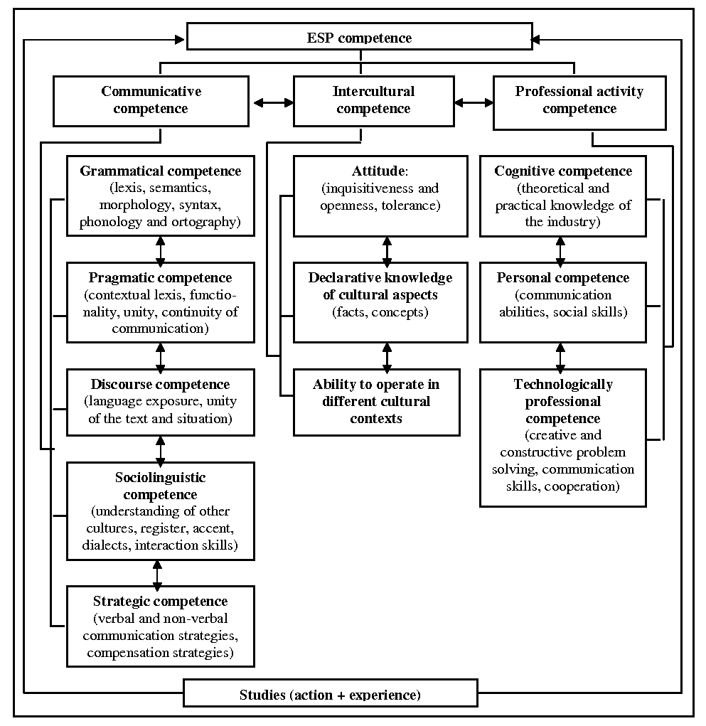
Fig. 1. ESP competence for tourism students
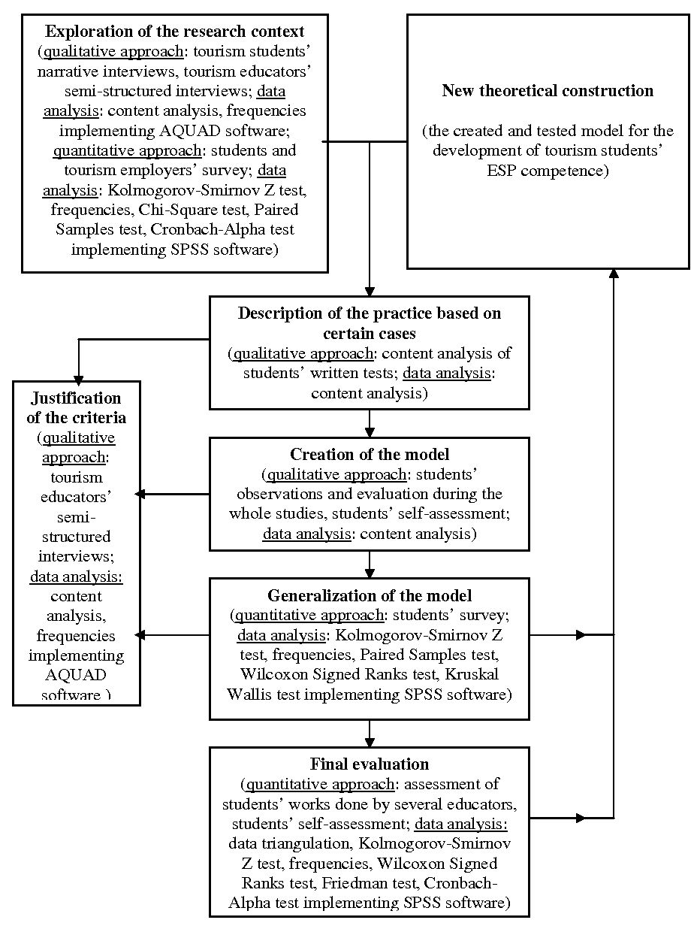

Fig. 2. The design of the research

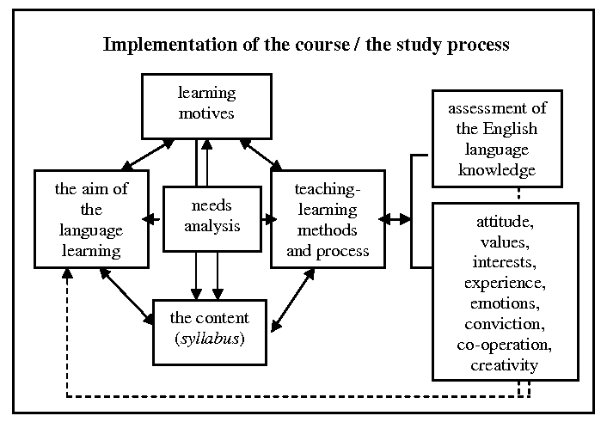
Fig. 3. The process model for the development of tourism students’ ESP competence

Appendix A
ESP competence criteria, indicators and levels

Criterion: Language use for professional duties
Indicator: Mutual oral communication
Proficient  user | 1. Understands a long and complicated speech about general and occupational topics  2. Can professionally communicate in English about occupational topics making a clear, well-structured speech and using lexis and grammar appropriate to the situation  3. Can deliver a speech concerning any tourism sphere, can justify their opinion, and maintain a conversation by asking and answering specific questions connected with the tourism industry
Independent user | 1. Understands the main ideas of a long and complicated speech about general and occupational topics  2. Can communicate in English about previously studied occupational topics making a clear, well-structured speech and using professional lexis  3. Can deliver a speech on a previously prepared professional topic, can maintain a conversation by asking and answering questions connected with their professional duties
Basic user | 1. Understands the main ideas of a simple, slow speech about general and occupational topics  2. Can communicate in English about previously studied occupational topics with a partner’s help  3. Delivering a speech on a previously prepared professional topic can briefly answer the questions connected with their everyday professional duties
 | Indicator: Understanding of a specialized professional text
Proficient  user | 1. Can in detail understand long, complicated professional texts  2. Can identify different language styles, can understand the slightest nuances of a professional text, directly and indirectly expressed opinions, and explain them  3. Can scan and skim long, complicated professional texts and find the required information in a little time
Independent  user | 1. Can understand professional texts connected with their everyday duties  2. Can find the main idea of a professional text and explain it using a sample text  3. Can scan and skim professional texts and find the required information using a dictionary to check the meaning of the terms
Basic user | 1. Can understand the main idea of the text, but is not able to convey detailed information  2. Poorly understands professional lexis in specific professional texts  3. Using a dictionary can scan and skim short professional texts in order to find the required information
 | Indicator: Business correspondence
Proficient user | 1. Can write clear, correctly structured business documents that correspond to the layout requirements  2. Can give accurate written answers to clients’ questions using appropriate professional lexis and without inclusion of irrelevant information  3. Spelling is accurate
Independent user | 1. Using samples of standard documents of the tourism industry can write similar business documents containing standard phrases and expressions  2. Can give written answers to clients’ questions using basic professional lexis and simple sentence constructions  3. Spelling contains slight mistakes; a student mixes British and American spelling
Basic user | 1. Using a dictionary can write a short business document according to the pattern substituting the given information by the required one  2. Can give written answers to clients’ questions imitating the pattern and using elementary sentence constructions  3. Spelling is inaccurate

Criterion: Professional thinking
Indicator: Cooperation
Proficient user | 1. Willingly works in pairs, listens to their partner, cheering them and maintaining the conversation  2. Is eager to communicate with group mates, expressing and proving their opinion and listening to others  3. Cooperates with a teacher by giving additional information and improving the teacher’s knowledge  4. Willingly participates in group work involving other students as well
Independent user | 1. Willingly works in pairs, takes the leading role in pair work sometimes even not allowing the partner to express their opinion  2. Expresses their opinion but does not show interest in other students’ opinions  3. Asks questions to the teacher about the themes that they do not understand but does not help with additional information  4. Participates in group work being encouraged by the teacher or group mates
Basic user | 1. Does not wish to do pair work, pretends being occupied by other work  2. Is not willing to express their opinion, gives answers only after repeated direct questioning  3. Does not ask any questions to the teacher but puts down the teacher’s answers to other students’ questions  4. While doing group work takes the observer’s position
 | Indicator: Creativity
Proficient user | 1. While performing creative tasks in language lessons uses original, untraditional solutions  2. The written text contains rich, creative language and original means of expressing their opinion and ideas  3. While performing problem solving tasks expresses untraditional, creative ways of problem solving  4. Creatively uses knowledge for occupational purposes
Independent user | 1. While performing creative tasks in language lessons uses previously learnt and/or implemented solutions  2. The written text contains creative language and previously used ideas that have been adapted according to the situation  3. While performing problem solving tasks uses previously acquired means of problem solving  4. Uses knowledge for occupational purposes, acting according to previously acquired patterns
Basic user | 1. Is not willing to perform creative tasks in language lessons  2. The written text consists of basic lexis and some creative means of expressing themselves and contains previously used ideas  3. Can perform a problem-solving task using others’ help and support  4. Uses knowledge for occupational purposes, with support and help received from colleagues and/or the employer

Criterion: Abilities of intercultural communication
Indicator: Openness and understanding
Proficient  user | 1. Creatively implements intercultural communication and cooperation skills in practice  2. Shows interest in cultural values of other nations, evaluates and compares them with the cultural values of their own culture  3. Has learnt different thinking styles and behaviour of other cultures, in practice creatively implements the acquired knowledge  4. Willingly accepts challenge, creatively uses new possibilities, is open to changes, is ready to work in different cultural contexts
Independent user | 1. Can use theoretically acquired communication and cooperation skills in similar situations  2. Has theoretically acquired cultural values of other nations but faces difficulties to compare them with the cultural values of their own culture  3. Has learnt different thinking styles and behaviour of other cultures, in practice implements the gained knowledge in similar situations  4. Accepts changes and uses new possibilities when being urged by somebody, is ready to work in different cultural contexts providing he/she receives others’ help
Basic user | 1. Can implement theoretically acquired communication and cooperation skills using somebody’s help  2. Has gained information about cultural values of other nations but does not express interest in them and/or evaluates their culture higher than other cultures  3. Has poorly learnt different thinking styles and behaviour of other cultures, can implement the acquired knowledge in practice using support of others  4. Rejects the use of new possibilities, gives priority to well known values, it is difficult to put themselves and work in different cultural contexts, using others’ support can work in a similar cultural context

Appendix B
Typical statements from the third year tourism students’ interviews to demonstrate their use of English at work (needs analysis)
Metacode | Student | Statement
Listening skills | Student 2 | It was necessary to understand clients, when they are speaking.
Listening skills | Student 3 | I needed to understand telephone conversations, listen to the guests’ complaints and their thoughts about our country, people, hotel, etc.
Listening skills | Student 5 | I had to answer the phone calls, register bookings, satisfy the clients’ wishes, including, their complaints, listen to their questions, understand the employer’s information, as well as everyday conversations among the personnel.
Listening skills | Student 6 | I didn’t have to use English in all at my work. [the student worked in a travel agency]
Reading skills | Student 1 | I didn’t have to read in English at all. [the student worked in a travel agency]
Reading skills | Student 4 | Some brochures and magazines.
Reading skills | Student 7 | It was necessary to read and understand letters, complaints and contracts.
Reading skills | Student 8 | 10% of my work was connected with reading: faxes, bookings done via e-mail, guests’ forms, guests’ registration cards, tourism brochures in order to show the guests where tourism objects are located.
Reading skills | Student 9 | To understand tourism brochures.
Writing skills | Student 5 | I had to take notes for the guests, write letters of confirmation, write messages, e-mails, faxes, letters, fill in registration cards.
Writing skills | Student 7 | Write letters and fill in the forms.
Writing skills | Student 8 | It was again 10% of the work: some refusals for hotel reservation, some confirmations for hotel reservation, giving information to the clients or business partners abroad (travel agencies, tour operating companies, etc.) written information for the guests how to find some tourism object.
Writing skills | Student 9 | I didn’t have to write at all. [the student worked in a hotel]
Speaking skills | Student 1 | I didn’t have to speak in English.
Speaking skills | Student 2 | Communicate with the clients, provide information or help if necessary.
Speaking skills | Student 3 | I had to speak about everything – checking in clients, providing information about hotel, breakfast, transport, escort services. I had to try to help everyone – someone needs medicine, another one can’t find the way somewhere or find the plane or coach timetable, the best restaurant, information about souvenirs and so on.

Appendix C
Typical statements from tourism educators’ interviews (needs analysis)
Metacode | Educators | Statement
the choice of teaching methods in the studies (MMIS metacode) | Educator 3 | The language learning process should be practically oriented, e.g., students practice dialogues from their professional setting.
 | Educator 6 | I think that people learn most efficiently when they are doing something. [..] Case studies are very useful because they make people look at the problems from a different angle.
 | Educator 7 | Students’ training in tourism enterprises is a factor that motivates students learn the language. It is like a stimulus that makes them learn a language, to see that something is happening.
 | Educator 8 | I don’t know if it can make language studies more interesting but it would be useful to do more self-study tasks connected with scientific literature as students have to write course papers. Reading, translating, writing a summary, analysing.
analysis of students’ language skills and language level (VPLA metacode) | Educator 1 | It is very complicated to stimulate the students’ reading. They read neither in English nor in their native tongue. They read very, very, very little. If a student does not read, he/she is not capable to synthesise and analyse the information. The educator provides a lot of information but the student cannot cope with it. His/her knowledge is fragmentary, like separate slides which the student is not able to “glue” together.
 | Educator 2 | Communication skills are the most important language skills in tourism hierarchy.
 | Educator 5 | I consider that the most important skill that students have to develop is a capability to scan a difficult professional text and in a very short time find the necessary information. The texts may be complicated, oversaturated with foreign words and strange constructions but they have to solve the situation at a short notice.
 | Educator 9 | As hotel guests are people whose native language is not English, tourism specialists have to develop a skill to express themselves concisely and using simple vocabulary. [..] They have to be able to communicate and speak about any topic.
 | Educator 12 | The most important language skills for studies by all means are reading and listening skills to understand information.
professional lexis necessary for work in the tourism business (SKNT metacode) | Educator 2 | The main problem the students come across while communicating in the tourism business is the specific lexis which is in English. Most of the hotel terms are in English. As the Latvian language does not have many of these terms, it is necessary to create new words that correspond to the original meaning. An example is ‘a receptionist’, which is often used in Latvian as ‘recepcionists’, which makes no sense in the Latvian language.
 | Educator 4 | Students have to know the lexis from catering industry and they must follow all the new tourism trends in tourism, hospitality, catering industry in Europe. They have to know the lexis for special equipment and work division in enterprises.
 | Educator 6 | Students have to know the basic tourism lexis, everything that is written in the Tourism Law.
 | Educator 10 | I consider that the most useful topics for tourism students are connected with hotels and telephoning, but I am not an expert in this field [teaches ITS for tourism students].
 | Educator 11 | Tourism students must know all the phrases of politeness, e.g., questions, requests, offers, etc.

Acknowledgements
The author would like to thank her scientific adviser of PhD Thesis Dr. habil. paed. prof. Irēna Žogla of the University of Latvia for her scientific advice and support during the whole period of PhD studies, as well as the authorities of the School of Business Administration Turiba, Latvia for the provided financial support.

References
Alijevs, R. (2005). Izglītības filosofija. 21.gadsimts. [Phylosophy of education. The 21st century.] Rīga: Retorika A.
Anisimova, A. (2006). Strategic Competence in the Context of Cultural Awareness. Available from http://www.tesolgreece.com [Accessed June 26, 2006].
Bachman, L.F., Palmer, A.S. (1982). The construct validation of some components of communicative proficiency. TESOL Quarterly, 16 (4), 451.
Bell, R.T. (1981). An introduction to applied linguistics: Approaches and methods in language teaching. London: Batsford Academic and Educational Ltd.
Bernstein, D.A., Penner, L.A., et al. (2003). Psychology. Boston: Houghton Mifflin Company.
Bruner, J. (1973). Constructivist theory. Going Beyond the Information Given. Available from http://carbon.cudenver.edu [Accessed May 1, 2006].
Byram, M. (1998). Intercultural Communicative Competence – the Challenge for Language Teacher Training. Teaching Towards Intercultural Competence: Conference Proceedings, (pp. 92-103). Sofia: British Council.
Byram, M. (2000). Assessing Intercultural Competence in Language Teaching. Sprogforum, 18 (6), 8-13.
Byram, M., Gribkova, B., et al. (2002). Developing the Intercultural Dimension in Language Teaching. Strasbourg: Council of Europe.
Canale, M. (1983a). On some dimensions of language proficiency. Oller, J.W. Jr. (Ed.), Issues in language testing research (pp. 333-342). Rowley, MA: Newbury House Publishers, Inc.
Canale, M. (1983b). From communicative competence to communicative language pedagogy. Richards, J. C., Schmidt, R. W. (Eds.), Language and communication (pp. 2-27). Rowley, MA: Newbury House Publishers, Inc.
Canale, M., Swain, M. (1980). Theoretical bases of communicative approaches to second language teaching and testing. Applied linguistics, 1 (1), 1-47.
Chatterji, M. (2005). Evidence on ‘What works’: an argument for extended-term mixed-method (ETMM) evaluation designs. Educational Researcher, 34 (5), 14-24.
Chishimba, C.P. (2001). Content-based Teacher Education Approach versus Competence-based Teacher Education Approach. Prospects. Quarterly review of comparative education, XXXI (2), 229-238.
Čehlova, Z. (2002). Izziņas aktivitāte mācībās. [Cognition activity in studies.] Rīga: RaKa.
Dirba, M. (2003). Latvijas identitāte: pedagoģiskais aspekts. [Latvian identity: pedagogic aspect.] Rīga: Izdevniecība RaKa.
Dirba, M. (2004). Intercultural learning and language teacher education. Collection of the selected papers presented at the ATEE 7th Spring University. European added value in teacher education (pp. 23-28). Tartu: University of Tartu.
Dunkelman, J.P. (1996). The Application of Selected Sociolinguistic Concepts to Second Language Learning Syllabus Design. Available from http://www.home.att.ne.jp/iota/puritycompany_dis.htm [Accessible January 22, 2004].
Elliott, J. (1998). The Curriculum Experiment. Meeting the Challenge of Social Change. Buckingham: Open University Press.
Ellis, R. (2005). Instructed Second Language Acquisition. Wellington: Ministry of Education, New Zealand.
Foster, P. (1999). Task-based learning and pedagogy. ELT Journal, 53 (1), 69-70.
Freeman, M., deMarrais, K., et al. (2007). Standards of Evidence in Qualitative Research: an Incitement to Discourse. Educational Researcher, 36 (1), 25-32.
Geske, A., Grīnfelds, A. (2006). Izglītības pētniecība. [Research in education.] Rīga: LU Akadēmiskais apgāds.
Gillet, A.J. (1989). Designing an EAP Syllabus: English Language Support for Further and Higher Education. Journal of Further and Higher Education, 13 (1), 92-104.
Hunter, A., Brewer, J. (2003). Multimethod research in sociology. Tashakkori, A., Teddlie, C. B. (Eds.) Handbook of Mixed Methods in Social & Behavioral Research (pp. 577-593). London, New Delhi: Sage Publications, International Educational & Professional Publisher. Thousand Oaks.
Kennedy, C. (1988). Evaluation of the management of change in ELT projects. Applied Linguistics, 9 (4), 332.
Kim, B. (2001). Social Constructivism. Available from http://www.coe.uga.edu/epltt/SocialConstructivism.htm [Accessed May 1, 2006].
Kim, D., & Hall, J. K. (2002). The Role of an Interactive Book Reading Program in the Development of Second Language Pragmatic Competence. The Modern Language Journal, 86/3, 332-348.
Klafki, V. (1992). Mācību plānošanas perspektīvā shēma. [Perspective scheme of planning of studies.] Gudjons, H. (Ed.) (2007). Pedagoģijas pamatatziņas [Pedagogic concepts.] (pp. 258-262). Rīga: Zvaigzne ABC.
Korhonen, K. (2004). Developing Intercultural Competence as Part of Professional Qualifications. A Training Experiment. Journal of Intercultural Communication, 7, 1-8. Available from http://www.immi.se/intercultural/ [Accessed June 10, 2006].
Kroplijs, A., Raščevska, M. (2004). Kvalitatīvās pētniecības metodes sociālajās zinātnēs. [Qualitative research methods in social sciences.] Rīga: Izdevniecība RaKa.
Lasmanis, A. (2002). Datu ieguves, apstrādes un analīzes metodes pedagoģijas un psiholoģijas pētījumos. (1. grāmata.) [Data collection, data processing and data analysis methods in pedagogic and psychologic researches. The first book.] Rīga: SIA Izglītības soļi.
Lund, K. (1996). Communicative competence – where do we stand? Sprogforum, 4, 7-19.
Markee, N. (2002). Managing Curricular Innovation. Cambridge: Cambridge University Press.
Maslo, I., Tiļļa, I. (2005). Kompetence kā audzināšanas ideāls un analītiska kategorija. [Competence as an ideal of eduaction and an analytic category.] Skolotājs, 3 (51), 4-9.
Maslo, I. (Ed.). (2006). No zināšanām uz kompetentu darbību. [From knowledge to competent action.] Rīga: LU Akadēmiskais apgāds.
Mayring, P. (2002). Einführung in die qualitative Sozialforshung. [Introduction into qualitative social research.] Beltz, Вasel: Beltz Verlag.
Mayring, P. (2004). Qualitative Content Analysis. Flick, U., von Kardoff, E., Steinke, I. (Eds.). A Companion to Qualitative Research. (pp. 266-269). London: Sage Publications.
McKay, L.S. (2002). Teaching English as an International Language. Oxford: Oxford University Press.
More, J. G. (2001). Lifelong Learning Policies in Spanish Universities. European Journal of Education, 36 (3), 317-327.
Nunan, D. (1991). The Learner-centred Curriculum. Cambridge: Cambridge University Press.
Pētersons, E. (1931). Vispārīgā didaktika. [General didactics.] Rīga: A. Gulbis.
Print, M., Ørnstrøm, S., Lielsen, H.S. (2002). Education for Democratic Process in Schools and Classrooms. European Journal of Education, 37 (2), 193-210.
Proposal for a Recommendation of the European Parliament and of the Council on key competences for lifelong learning. Brussels, COM(2005) XXX. Available from http://ec.europa.eu/education/policies/2010/doc/keyrec_en.pdf [Accessed January 6, 2006].
Rabbini, R. (2002). An Introduction to Syllabus Design and Evaluation. The Internet TESL Journal, 8 (5). Available from http://www.iteslj.org/Articles/Rabbini-Syllabus.html [Accessed May 12, 2004].
Raščevska, M., Kristapsone, S. (2000). Statistika psiholoģiskajos pētījumos. [Statistics in research in psychology.] Rīga: Izglītības soļi, 2000.
Reichert, S., Tauch, C. (2003). Trends 2003. Progress towards the European Higher Education Area. Trends, 1, July, 1-131.
Reichert, S., Tauch, C. (2005). Trends IV: European Universities Implementing Bologna. Brussels: European University Association.
Reilly, T. (1988). Approaches to Foreign Language Syllabus Design. Available from http://www.ericfacility.net/databases/ERIC_Digests/ed.html [Accessed January 22, 2004].
Renard, P. (2001). The speech during the closing ceremony of the Forty-sixth Session of the International Conference on Education. Geneva, 5-8 September 2001. Educational Innovation and Information, 109, 1-7.
Richards, J.C. (2001). Curriculum Development in Language Teaching. Cambridge: Cambridge University Press.
Richards, J.C., Lockhart, C. (1994). Reflective Teaching in Second Language Classrooms. USA: Cambridge University Press.
Robertson, S.L. (2005). Re-imagining and rescripting the future of education: global knowledge economy discourses and the challenge to education systems. Comparative Education, 41 (2), 151-170.
Rooney, K. (2000). Redesigning Non-Task-Based Materials to Fit a Task-based Framework. The Internet TESL Journal, VI (12). Available from www.iteslj.org/Techniques/Rooney-Task-Based.html [Accessed June 1, 2004].
Sdorow, L. (1990). Psychology. Dubuque: Wm. C. Brown Publishers.
Siegel, H. (2006). Epistemological diversity and education research: much ado about nothing much? Educational Researcher, 35 (2), 3-12.
Skelton, J., Willis, J. (2004). Approaches to Syllabus Specification. Course and Syllabus Design – Unit 1. Available from http://www.philseflsupport.com [Accessed January 22, 2004].
Spolsky, B. (1998). Conditions for Second Language Learning. Oxford: Oxford University Press.
Stier, J. (2004). Intercultural competencies as a means to manage intercultural interactions in social work. Journal of Intercultural Communication, 7, 1-17. Available from http://www.immi.se/intercultural/ [Accessed June 10, 2006].
Stier, J. (2006). Internationalisation, intercultural communication and intercultural competence. Journal of Intercultural Communication, 11, 1-12. Available from http://www.immi.se/intercultural/ [Accessed June 10, 2006].
Tarone, E., Yule, G. (1989). Focus on the Language Learner. Oxford: Oxford University Press.
The Definition and Selection of Competencies: Executive Summary. Available from http://www.oecd.org/dataoecd/47/61/35070367.pdf [Accessed October 26, 2008].
Tiļļa, I. (2003). Pusaudžu sociokultūras kompetences pilnveide otrās svešvalodas mācību procesā. [Development of adolescents’ socio-cultural competence in the Second language acquisition process.] Promocijas darbs. Rīga: Latvijas Universitāte.
Tiļļa, I. (2005). Sociokultūras mācīšanās organizācijas sistēma. [The organizational system of socio-cultural learning.] Rīga: Izdevniecība RaKa.
Vygotsky, L. (1978). Social Constructivism. Mind in Society. Available from http://carbon.cudenver.edu [Accessed May 1, 2006].
Vigotskis, Ļ. (2002). Domāšana un runa. [Thought and language.] Rīga: Izdevniecība “EVE”.
Widdowson, H.G. (1979). Explorations in Applied Linguistics. Oxford: Oxford University Press.
Williams, M., Burden, R.L. (1999). Psychology for language teachers. Cambridge: Cambridge University Press.
Willis, J.A. (1998). Framework for Task-based Learning. Harlow: Wesley Longman Ltd.
Wilson, D. (2001). Reform of TVET for the Changing World of Work. Prospects. Quarterly review of comparative education, XXXI (1), 21-37.
Yalden, J. (1996). Principles of Course Design for Language Teaching. Cambridge: Cambridge University Press.

